COURSE CODE/TITLE: | CPE 010 |  | SECTION: | CPE21S3
DATE PERFORMED: | 9/17/26 |  | DATE SUBMITTED: | 9/23/26
NAME: | Ralf Nicolo B. Abello |  | INSTRUCTOR: | Engr. Jimlord Quejado

ACTIVITY NO. 9.1 | Implementing Trees
1. PROCEDURE OUTPUT
ILO A
Task 1
main.cpp
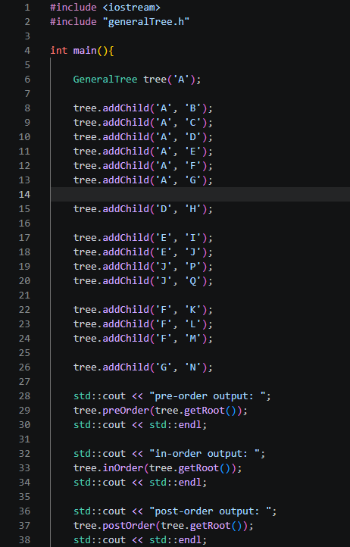
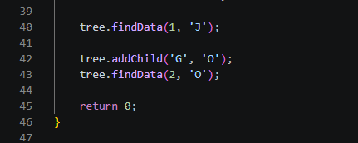

generalTree.h
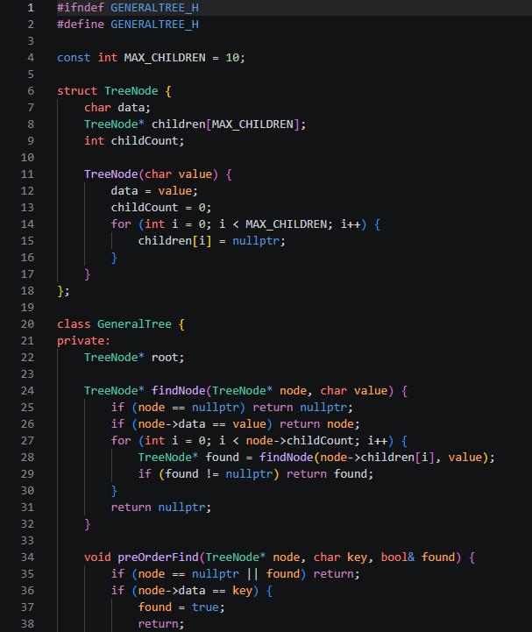
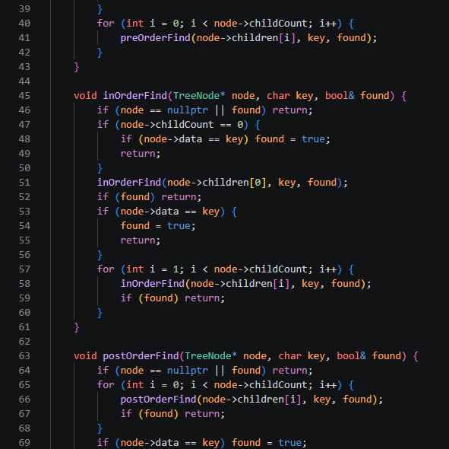
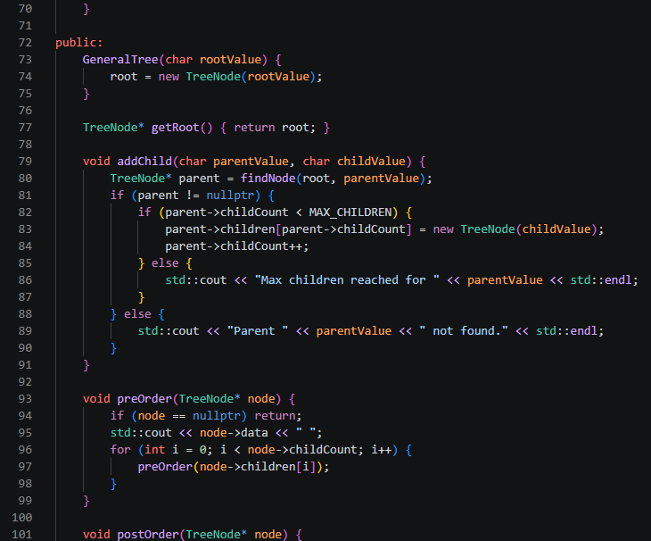
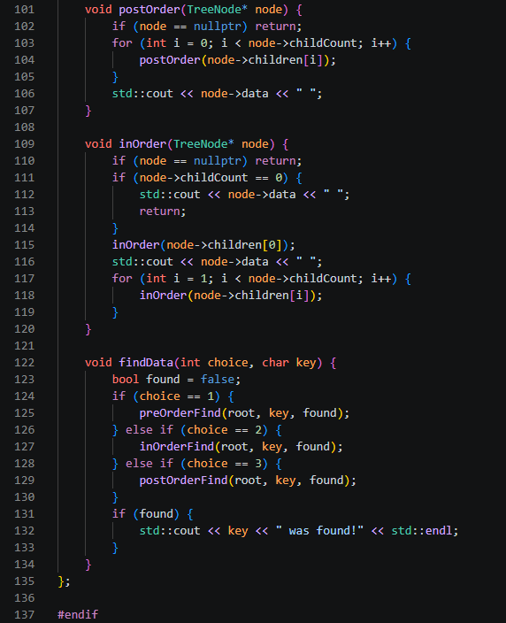

addChild() locates the parent by value with a recursive search, then appends the new child into the parent's fixed-size children array. This produces the exact shape of the diagram: A has six children (B, C, D, E, F, G); D has one child (H); E has two children (I, J); J has two children (P, Q); F has three children (K, L, M); G has one child (N).

Task 2
Table 9-2: Height and Depth of Every Node

Node | Height | Depth
A | 3 | 0
B | 0 | 1
C | 0 | 1
D | 1 | 1
E | 2 | 1
F | 1 | 1
G | 1 | 1
H | 0 | 2
I | 0 | 2
J | 1 | 2
K | 0 | 2
L | 0 | 2
M | 0 | 2
N | 0 | 2
P | 0 | 3
Q | 0 | 3
Depth is the number of edges from the root to the node; height is the length of the longest downward path from that node to a leaf. The height of the whole tree (root A) is 3, coming from the path A → E → J → P (or Q).

Task 3.1
Table 9-3: Traversal By Hand

Pre-order | A, B, C, D, H, E, I, J, P, Q, F, K, L, M, G, N
In-order | B, A, C, H, D, I, E, P, J, Q, K, F, L, M, N, G
Post-order | B, C, H, D, I, P, Q, J, E, K, L, M, F, N, G, A

Task 3.2
Traversal Functions, Output, and Observations
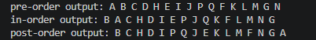

Observation
the program's output for all three traversals matches the by-hand results in Table 9-3 exactly. Pre-order and post-order are unambiguous for any tree shape since they only depend on visiting a node before or after its children. In-order needed an explicit convention because it is only naturally defined for binary trees; once that rule was fixed (first child, then node, then remaining children), the function output matched the hand-computed sequence.

ILO B
Task 3.3
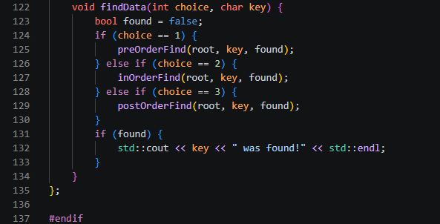

Task 3.4
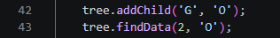

Observation
O becomes the second child of G, alongside N. findData now succeeds for O under any traversal choice since O appears in all three traversal orders. The most visible structural change is in the in-order traversal: G previously had a single child (N), so inOrder(G) produced N, G; with two children it becomes N, G, O, since the generalized in-order rule visits the first child, then the node, then the remaining children. Pre-order and post-order shift only by O being appended immediately after N wherever G's subtree is visited.

2. ANSWERS TO SUPPLEMENTAL ACTIVITY
main.cpp
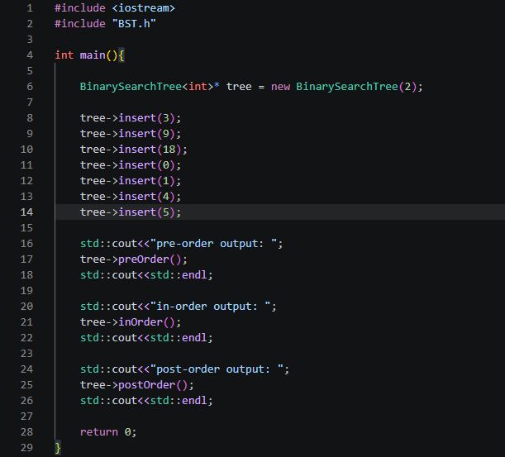

binaryTree.h
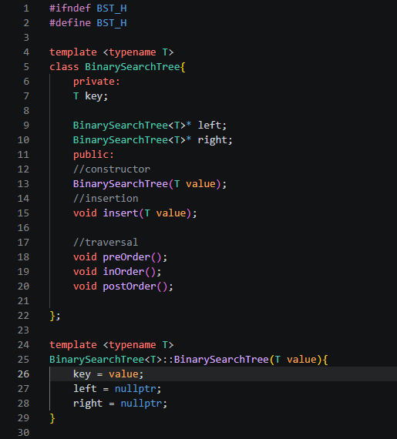
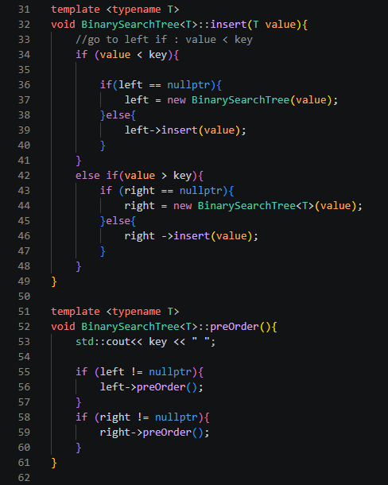
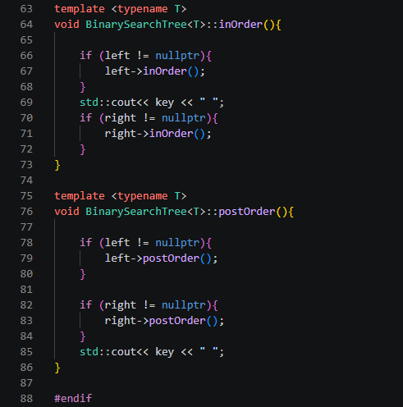

Tree Diagram
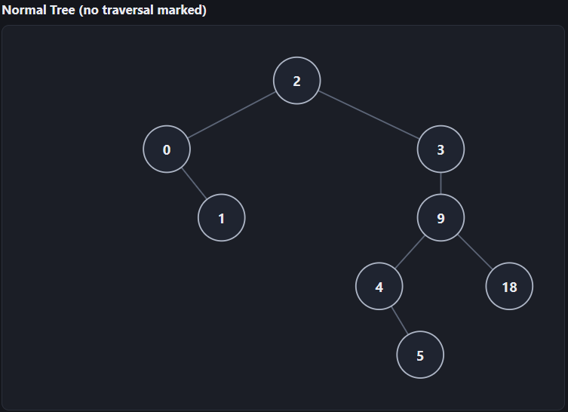
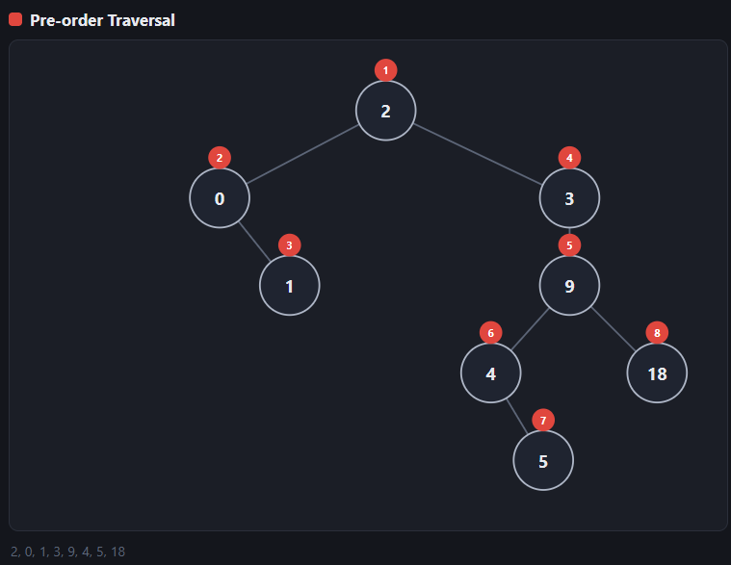
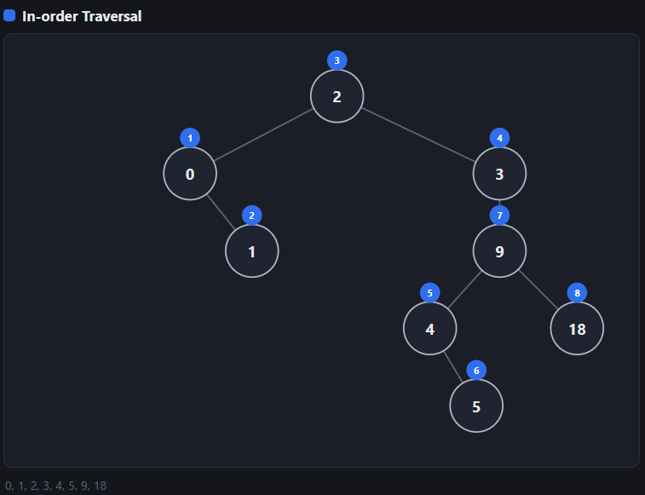
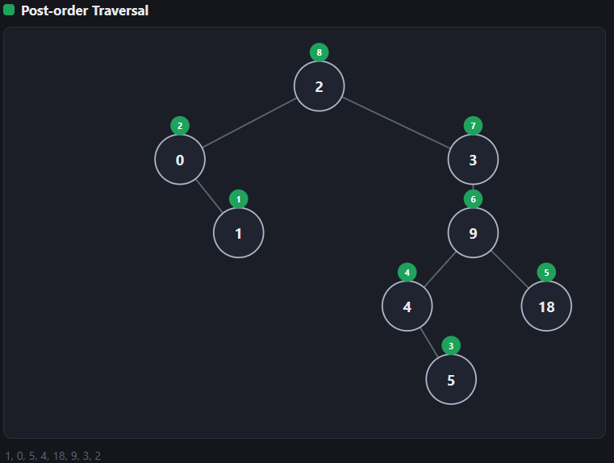

In-order Traversal
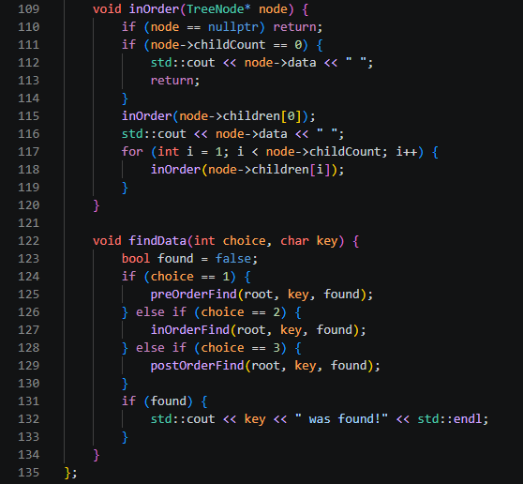

Pre-order Traversal
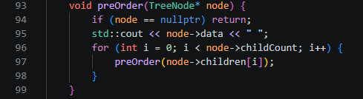

Post-order Traversal
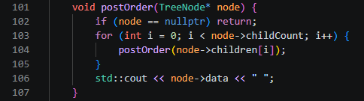

Conclusion
This activity built and traversed both a general tree, where a node can have any number of children stored through a header file (GeneralTree.h) separate from main.cpp, and a binary search tree, where each node has at most two children ordered by value; implementing pre-order, in-order, and post-order traversal recursively for each structure showed that in-order only has a natural definition for binary trees and needs a generalized rule for wider trees, and confirmed why in-order is the traversal of choice on a BST since it is the only one that produces sorted output, while pre-order and post-order instead reflect the tree's shape and insertion history.

3. ARTIFICIAL INTELLIGENCE (AI) USE DISCLOSURE STATEMENT
I hereby declare that artificial intelligence (AI) tools were used, if applicable, in the preparation of this academic work. The following indicates the nature and extent of AI assistance:

Tools Used: | Grammarly & ChatGPT
Examples: ChatGPT, Microsoft Copilot, Grammarly, QuillBot, etc.

Purpose of Use: | Grammar correction & code assistance
Examples: grammar correction, idea generation, formatting, summarization, code assistance, explanation of concepts, etc.

Extent of Use: | Used AI to assist me debug my code while also explaining the process on how it works
Explain how AI was used and confirm that it did not replace original thinking, analysis, authorship, or completion of the required work.

By submitting this activity, I affirm that my use of AI complies with T.I.P.’s AI usage policy and does not exceed the permitted limits for similarity, automated content generation, or academic assistance.

I understand that any false, incomplete, or misleading disclosure may be subject to investigation in accordance with due process and may result in sanctions for violation of existing T.I.P. policies.

Lab activities, templates, and related instructional materials shall not be reuploaded, reproduced, distributed, or shared with external organizations or third parties without the prior express written permission of the Technological Institute of the Philippines.

